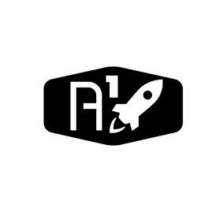

DESIGN DOCUMENT

Area : Converse Engine

Category: Feed (Piping)

TEAM: Propulsion

Nyameaama Gambrah

**THERMOCOUPLE**

CLK

CS

DO

GND

VCC

D-Pin

D-Pin

D-Pin

5V

GND

ECU

AD595 Thermocouple Amplifier

T-C